Save the Date

The 24th Annual
Maryland Multicultural Coalition Conference
The state chapter of the National Association for Multicultural Education
April 22, 2017
Marriotts Ridge High School
12100 Woodford Dr. Marriottsville, MD 21104
Hosted by the Howard County Public School System

The theme for this year’s conference is
The Journey to Excellence with Equity in Education
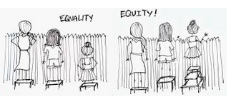

Registration to begin in mid-February. Check the MMC website at mdmc.edublogs.org for more information or email mdmulticultural@gmail.com

