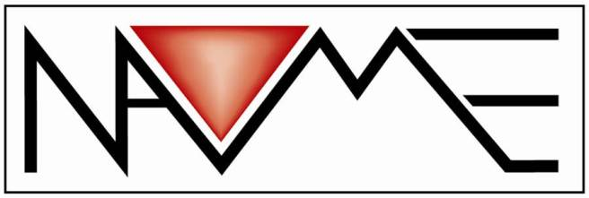
Maryland Multicultural Education Conference

Hosted by Carroll County Public Schools
and
The Maryland Multicultural Coalition,
State Chapter of the
National Association for Multicultural Education (NAME)

2019 Conference:

Saturday, April 6, 2019
8:00 a.m. to 2:30 p.m.

Winters Mill High School
Westminster, MD

Deadline for Proposals:
February 1, 2019

NAME is committed to an anti-discrimination policy in all of its programs and services. NAME is consciously and proactively inclusive of all areas of diversity including, but not limited to, race, ethnicity, color, national origin, ancestry, gender, sexual orientation, gender identity, religion, age, socioeconomic status, language, disability, or immigration status.

Maryland Multicultural Coalition State Conference
April 6, 2019

Maryland Multicultural Coalition and Carroll County Public Schools are looking for engaging and inspiring presentations that highlight our conference theme, “Working Together to Build a Legacy of Equity and Excellence.” Our hope is to provide diverse offerings to our educators in the areas of awareness, application and advocacy.

Please complete the form below and submit via email to
mmc42019@gmail.com by February 1, 2019.

Description of Presentation Proposal

- Title of Presentation: Click here to enter text.

- Abstract (Use 50 words or less. This information will also be printed in the program booklet.): Click here to enter text.

- Outcomes: Click here to enter text.

- Content: Click here to enter text.

- Theme Alignment: How does your presentation align with the theme of the conference, “Working Together to Build a Legacy of Equity and Excellence.” Click here to enter text.

- Session Format: (All presentations should be 65 minutes and as interactive as possible)

☐Presentation- Delivery of information from the presenter with limited opportunity for interaction.
☐Workshop – hands-on activities and practical application, including active involvement from participants
☐Culture Chat – an interactive forum for the purpose of developing dialogue, greater understanding, recommendations, collaboration, or other efforts

- Tiers of Focus
  - Awareness ☐
  - Application ☐
  - Advocacy ☐

Education Level Addressed (please check all that apply):
☐Elementary ☐Middle School
☐High School ☐Adult Education
☐Higher Education

Target Audience (please check all that apply):
☐Teachers ☐Staff Developers
☐Administrators ☐Community Activists
☐Teacher Education ☐ESOL Teachers
☐Curriculum Specialists ☐State Education
Other: Click here to enter text.

Logistics: Would you present at one or both sessions?
☐One Session ☐Both Sessions
Sessions are 65 minutes in length; sessions will run from 9:45 to 10:50 and 11:00 to 12:05

Name of Presenter 1: Click here to enter text.

Title of Presenter: Click here to enter text.
Organization/School: Click here to enter text.
E-mail: Click here to enter text.

Telephone: Click here to enter text.

Address: Click here to enter text.
City: Click here to enter text.
State: Click here to enter text. Zip code: Click here to enter text.

Name of Presenter 2: Click here to enter text.

Title of Presenter: Click here to enter text.
Organization/School: Click here to enter text.
E-mail: Click here to enter text.

Telephone: Click here to enter text.

Address: Click here to enter text.
City: Click here to enter text.
State: Click here to enter text. Zip code: Click here to enter text.

Name of Presenter 3: Click here to enter text.

Title of Presenter: Click here to enter text.
Organization/School: Click here to enter text.

E-mail: Click here to enter text.

Telephone: Click here to enter text.

Address: Click here to enter text.
City: Click here to enter text.
State: Click here to enter text. Zip code: Click here to enter text.

- Audio/visual Equipment:
The ability to display presentations via LCD is available in each room. Additional technology needs must be provided by presenters.

PLEASE NOTE: Presenters are responsible for 40 handouts per session. If your presentation is accepted, you are required to register for the conference and pay a $25.00 registration fee.

Please send proposals to: Laurie Namey at
mmc42019@gmail.com by February 1, 2019.
Email submission only!
Please save as the following format: lastname_mmc

For More Information Contact:

Judith Jones
2019 Conference Chairperson
Supervisor of Equity and Community Outreach
Carroll County Public Schools

JIJONES@carrollk12.org

410-386-1680

Laurie A. Namey

Maryland Multicultural Coalition Vice-President

Supervisor of Equity & Cultural Proficiency

Harford County Public Schools

laurie.namey@hcps.org

410-809-6065

